Logo of United States Agency for International Development

USAID Global Health Supply Chain Program

Technical Assistance, National Supply Chain Assessment Task Order

HealthlandSupply Chain Action Brief

NSCA 2.0

Logos of USAID, Center for disease control and prevention and Department of Health & Human Services



# Brief Summary

Healthland is working to ensure sustained access to quality essential medicines and health supplies for all Healthlandians. Healthland’s National Supply Chain Strategy (2013-2018) articulates this vision, the successes and challenges of the country’s supply chain, and the objectives it has set out to improve medicines access. The government, central medical stores, and development partners have invested in the supply chain over many years to improve the supply chain system, but gaps remain. A National Supply Chain Assessment was conducted in early 2018 to provide information to support the development of an updated national supply chain strategy and continued supply chain improvement. 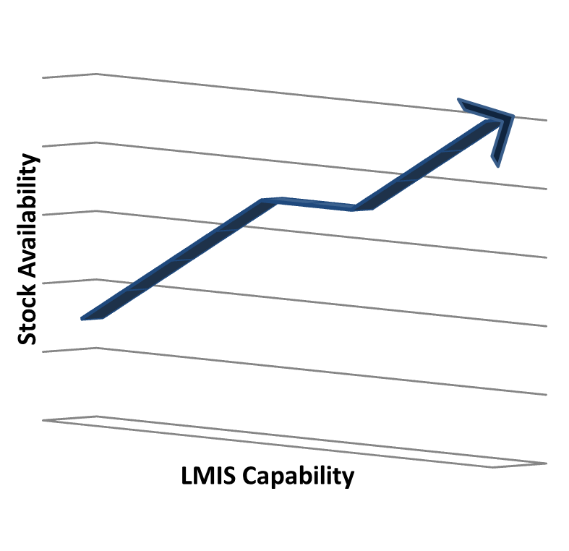

Key findings from this report indicate that many of the key capabilities needed for a high performing health supply chain exist in Healthland but are not consistently achieved throughout the system. In several supply chain functions, some capabilities are already advanced, while other more basic capabilities are still needed. This capability mix suggests that increasing basic capabilities in some critical functions will support rapid progress. One such area is strengthening use of the electronic LMIS (eLMIS) system, to ensure the health system has the data required for optimizing supply chain performance and for health program management.

The recently introduced eLMIS system is a positive addition in the supply chain; it is performing well where there is appropriately maintained equipment and sufficient, trained human resources. In service delivery sites and primary care hospitals that utilize the eLMIS system well, stock out rates were lower than in facilities that were using the eLMIS (see below). This observation suggests that a focus on improving eLMIS usage could improve access to essential medicines.

Interventions that are likely to improve eLMIS usage include targeted training for human resources (to ensure proper awareness of and skills for eLMIS), conducting regular data quality assessments and providing needed support, and retiring the duplicate paper LMIS system to reduce the burden on health workers. This brief further explains the data and details specific actions to increase the utilization of the eLMIS and its potential to translate into reductions in stock outs of medicines and essential supplies.

***Actions to Increase eLMIS Capability***

* *Consolidate the eLMIS efforts by retiring the paper-based system*
* *Train health workers for specific, required eLMIS capabilities*
* *Conduct regular data quality assessments and provide appropriate follow-up support*

# Summary of Evidence

Current levels of eLMIS maturity for different levels of the health system can be found in the bar chart below. Each bar spans from the minimum to the maximum score for LMIS Capability across the entities included in the assessment, with the line in the middle representing the average.

LMIS capability at health centers and primary hospitals is highly variable

The supply chain system demonstrates a range of LMIS Capabilities, and lower levels of the health system show greater variability. Many factors contribute to this wide variation in LMIS capability at lower levels – including whether the eLMIS has been rolled out to the facility, whether appropriate equipment is available and reliable, and whether the staff have been trained in LMIS and receive supportive supervision. Sites which receive regular data quality audits also appear to make better use of the eLMIS system, providing more complete, accurate and timely information.

At health centers and primary hospitals, LMIS Capability scores showed a negative relationship with the percent of tracer products that were stocked out in the last six months (see graph, next page). This observation suggests that a focus on achieving high scores for eLMIS at these levels of the health system could have a significant impact in reducing stock out rates. This is consistent with supply chain principles, since the data provided by LMIS plays a critical role in enabling good supply chain decision-making and ensuring sites remain stocked up.

.

Analysis of capabilities, as well as anecdotal evidence from site visits, indicated several challenges for eLMIS and interventions that are likely to improve eLMIS use. Staff at sites with low LMIS capability tended to lack the specific skills required for eLMIS use or to understand its benefits; targeted training of responsible staff can help overcome this challenge. Where staff are overburdened or uncomfortable with the eLMIS, then tend to only use the legacy paper LMIS system; this system is duplicative, provides less data visibility, and is more prone to errors. Phasing out the paper LMIS system in all sites with access to eLMIS would reduce the burden on staff and improve their eLMIS reporting. Conducting regular data quality assessments leads to better eLMIS use and data quality, if followed up with appropriate support. In some sites, roll out of the eLMIS or additional equipment is also required.

# Conclusions

The National Supply Chain Assessment (NSCA) results indicate that many of the key capabilities needed for a high performing health supply chain exist in Healthland, but they are not consistently achieved throughout the system. The full assessment report indicates several existing challenges that should be addressed in Healthland’s new supply chain strategy. One critical area of focus will be strengthening use of the eLMIS system and the data it provides. A focus on effective use of the eLMIS system will provide more complete and higher quality data, leading to improved planning (e.g., demand forecasting, supply plans, distribution planning) and operations (e.g., pharmacy and stock management, order management) for the supply chain. This brief describes several eLMIS interventions that, if supported by the government and partners, are likely to raise performance levels, medicines availability, and value for money throughout the system.

# Detailed Recommendations

In order to ensure that health commodities reach the necessary health facilities and, ultimately, patients, two key actions are recommended for continued improvement of the eLMIS system throughout Healthland. In addition to the two recommendations below, the assessment also suggests that retiring the paper LMIS system in sites with the eLMIS will improve usage - by reducing duplication, easing the burden on staff, and consolidating all efforts on one system.

## Recommendation One: Implement Professional Development Training Specific to ELMIS for Health Care Workers.

Regular and standardized training is not currently in place, and that challenges exist identifying professionally qualified staff to effectively complete supply chain related tasks in the various health facilities. The development and deployment of professional development training related to supply chain and eLMIS could result in an increased number of qualified professionals to draw on for supply chain related needs, standardized approaches used across the supply chain system, increased use of the eLMIS system, and improved quality of data entered into the eLMIS system. This recommendation is directly linked to improving the effective use of eLMIS.

## Recommendation Two: Support Staff to Use the elmis Well by Conducting Regular Data Quality Assessments and Providing the Needed Follow-up Support.

Training alone will not be sufficient to sustain good eLMIS use. Supportive supervision and data quality assessments should be conducted to identify facilities where data is not being reported, is not complete, or not accurate. In facilities that demonstrate these challenges, plans should be set in place with facility management and higher-level authorities to provide the ongoing support and oversight required. This will build capability of staff in their work setting, will translate directly to better data quality, and will allow focusing resources on sites that need support.

# Methodology

The assessment examined the capability and performance of the pharmaceutical supply chain system, utilizing the NSCA 2.0. The toolkit measured the capability, functionality, and performance of supply chain functions at all levels of Healthland’s national health supply chain system through a process of data collection and interviews at sample sites. The NSCA 2.0 toolkit is comprised of three primary elements: Supply Chain Mapping, the Capability Maturity Model (CMM) tool, and the Key Performance Indicators (KPIs). The assessment sampled the central warehouse, 5 regional warehouses, 5 regional hospitals, 15 primary hospitals, and 45 health centers. The NSCA 2.0 is a standardized global tool that measures supply chain capability based on a maturity model and a core set of KPIs data were collected for a set of performance measures (such as stock-out rate, or on time delivery) using tracer commodities.

# References

1. Federal Republic of Healthland National Supply Chain Assessment: Full Report. (2018).
2. Federal Republic of Healthland. (2013). National Supply Chain Strategy (2013-2018).
3. Federal Republic of Healthland. (2012). National Health Policy.