USAID GLOBAL HEALTH SUPPLY CHAIN PROGRAM

Procurement and Supply Management

Technical Report

Supply Chain Information System Assessment Maturity Model (SCISMM) Assessment Report

Ministry of Health (MoH), Malawi

**Date: July 2021**



**Document Revision History**



| **Date** | **Document Version** | **Document Revision Description** | **Document Author** |
| --- | --- | --- | --- |
|  |  | Initial Document | Jean Miller |
|  |  |  |  |
|  |  |  |  |
|  |  |  |  |
|  |  |  |  |
|  |  |  |  |

**TABLE OF CONTENTS**

1. Executive Summary 1

2. overview OF SCISMM 3

2.1. Background 3

2.2. Structure of SCISMM 3

2.3. Maturity Levels 4

2.4. Supply Chain Maturity Score and Maturity Level 5

3. SCIS Assessment methodologies and plan 6

3.1. Planning of TA Execution 6

4. Task Schedule and plan 8

4.1. Review Documents 8

4.2. Interview Schedule 8

4.3. Information System Identified 9

5. Maturity Score and Observations – CMST Supply Chain operation 11

5.1. Information Systems/Tools Leveraged 11

5.2. SCISMM score dashboard 11

5.3. SCISMM Maturity Level Chart 11

5.4. Score and Maturity Level Analysis 12

6. Maturity Score and Observations – GHSC-PSM Supply Chain Operation 17

6.1. Information Systems/Tools Leveraged 17

6.2. SCISMM score dashboard 17

6.3. SCISMM Maturity Level Chart 18

6.4. Score and Maturity Level Analysis 18

7. Systems operation at facility level Observed 23

8. next stepS 24

8.1. SCISMM Q&A 24

**LIST OF TABLES**

Table 1: Schedule and Participants of the Assessment 8

Table 2: Summary of Information Systems in Country 9

**LIST OF FIGURES**

Figure 1: Definition of SCISMM Maturity Level 4

Figure 2: SCIS Score Dashboard – CMST 11

Figure 3: SCISMM Maturity Level Chart – CMST 12

Figure 4: SCISMM Score Dashboard – GHSC-PSM 17

Figure 5: SCISMM Maturity Level Chart – GHSC-PSM 18

Figure 6: LMIS systems at health facility 23

# Executive Summary

Today, there are numerous parallel supply chains (PSC) for health products in Malawi, managed by different stakeholders. More than twenty (20) information systems have been implemented independently to support the supply chain operation for various programs by each stakeholder.

The existence of parallel reporting systems has created structural challenges and weakened the mainstream monitoring and evaluation system. Data quality is still poor due to challenges in recording, extracting and reporting data, with some of facilities not able to collect and submit the required data on time.

The MoH aims to establish a unified and integrated health digital system to provide high quality, and routinely available data for decision making. Health technical policy and relevant technologies have been developed (or are being developed) to achieve this goal. Strengthening existing coordination mechanisms to maximize harmonization within department, institutions and partners is crucial to avoid duplication and inefficiency. Creating an integrated information system is the primary objective of the MoH to improve the health service to patients and building capacity in staff for planning, management, and decision-making.

The Supply Chain Information System Maturity Model (SCISMM) assessment was planned to evaluate the maturity of the current information systems (IS) and tools implemented in country, and to identify recommendations to address the potential missing features and or capabilities in the design of the information systems and current supply chain operation. Refer to section 2 for detailed background description of SCISMM tool.

The SCISMM assessment Short Term Technical Assistance (STTA) was conducted for the duration of June 7 – 19th, 2021 in Lilongwe, Malawi led by the PSM consultant. Due to the COVID-19 global pandemic, some of interview sessions were conducted virtually. Method of the assessment consists of document review, in person interviews with key stakeholders, and system demonstration. Refer to section 3 for the detailed assessment methodologies and plan.

An in-brief session with USAID Mission was held on June 3rd to kick-off the task. An assessment plan was reviewed daily to confirm the schedule, approximated 15 participants were interviewed throughout the two-week duration. An overview of the SCISMM tool, objectives, and processes of the SCISMM execution, as well as the next step were presented at the beginning of each interview session to participants. Refer to Section 4 for the daily schedule and organization visited.

More than 20 information systems have been implemented in country to support operation for all health programs. Currently, all systems are operated independently without automated integration with the others. Excel spreadsheets are used for data importing and exporting for data sharing and reporting purpose which required extensive effort to improve data quality for data analysis. Refer to section 4.3 for the summary of Information Systems identified.

As there are numerous parallel supply chains (PSC) for health products in Malawi, the SCISMM assessment was conducted focusing on two (2) supply chain operations; the MOH supply chain operation and the GHSC-PSM supply chain operation for program products supported by USAID, as these two covers most of the public health operations nationwide. Refer to section 5 and section 6 for detailed assessment observations and score charts.

During the SCISMM assessment, two electronic logistics management information systems (LMIS) implemented at health facilities for a different purpose were observed. The two systems may be able to provide an end-to-end data visibility of the supply chain operation if a detailed integration method was defined and implemented. Refer to section 7 for details.

General observations through the SCISMM assessment include but are not limited to:

* Parallel supply chain (PSC) operation in country with the MOH leads the supply chain operation for the essential medicines, while the implementing partners manage the supply chain operation for disease-specific program products.
* More than twenty IT solutions (systems) have been implemented by donors and partners in supporting their own supply chain operation. All systems are operating independently without integration which requires extensive resource effort for quantification and planning.
* Lack of unified national supply chain operation practice for all health programs which leads to substantial resource requirements for task execution.
* Lack of timely communication and coordination within departments, institutions, and partners to avoid duplication and inefficiency.
* The supply chain transformation plan and digital strategy have been developed and approved by the senior management to build a unified digital ecosystem for efficient and effective operation to serve patients.
* An interoperability platform is under development to support the unified digital ecosystem. A comprehensive and coordinated design and development plan among all stakeholders would be crucial to achieve the objective.

Refer to section 8 for recommendation of next step.

# overview OF SCISMM

## Background

USAID supply chain technical assistance programs heavily invested in information systems as a means of achieving contraceptive security. In FY18, GHSC-PSM developed with USAID the Supply Chain Information System Maturity Model (SCISMM) to meet the needs of countries and technical assistance providers in assessing and implementing standards-based information systems that reflect best practices.

SCIS Functionalities have been organized based on the Supply Chain Operations Reference (SCOR) model and the American Productivity & Quality Center (APQC) Process Classification Framework. The tool details information system capabilities in public health supply chains based on the SCOR model and provides a framework for adopting a progressive implementation for supply chain information systems.

SCISMM was intended to be used as an assessment tool to evaluate the maturity status of information systems (IS) implemented in country for the supply chain operation. Outcome of the assessment will

1. Provide maturity analysis of the As-Is ISs implemented
2. Outline the strength, weakness and opportunities for improvement
3. Propose MIS improvement roadmap and prioritize activities
4. Define performance indicator for continuous improvement

## Structure of SCISMM

The SCISMM questionnaires are organized based on eight (8) key function categories of supply chain operation. The structure of the SCISMM questionnaire consists of function category 🡪subfunction 🡪 activity. The function categories and associated subfunctions are as follows:

1. Forecasting & Planning System
   1. Demand/Consumption Planning
   2. Supply Planning
2. Procurement System
   1. Procurement Processing
   2. Fulfillment Visibility
3. Supplier & Contract Management System
   1. Sourcing
   2. Tender Management
   3. Supplier Information Management
4. Order Management
   1. Requisitioning
   2. Requisition Approval
   3. Inventory Visibility
   4. Requisition Fulfillment
   5. Order Visibility
5. Warehouse Management System
   1. Inbound Processing
   2. Inventory Management
   3. Outbound Processing
6. Transportation Management System
   1. Route Management
   2. Transportation Execution
   3. Freight Audit and Payment
7. Track and Trace
8. Commodity Tracking
9. Commodity Tracing
10. Authentication / Verification
11. Data Exchange and Management
    1. Data Exchange
    2. Product Master Data Management
    3. Facility Master Data Management
    4. Supplier Master Data Management

## Maturity Levels

Five (5) maturity levels are defined for each SCIS function category including:

* **Level 1: Reporting Based**

Manually driven processes using paper based or stand-alone reporting-based tools

* **Level 2: Transactional**

Basic automation of processes through transactional systems

* **Level 3: Advanced Digitization**

Advanced digitization of majority of processes Integrated workflows across critical supply chain functions

* **Level 4: End to End Visibility** (Integration & Data Exchange)

Visibility across all supply chain functions enabled by automated data exchange across all supply chain systems

* **Level 5: Digital Ecosystem** (Collaboration)

Collaborative processes across various Ecosystems

Diagram below summary the definition and scope of each maturity level.

Figure 1: Definition of SCISMM Maturity Level



## Supply Chain Maturity Score and Maturity Level

Two dashboards are generated via the SCISMM interview: the SCISMM score dashboard and maturity level chart of each supply chain functional category.

The SCISMM tool provides two analysis dashboards to indicate the As-Is operation per responses received from interviewees at their organization: the SCIS score chart and the SCIS maturity level bar chart.

* SCIS Score Chart: it provides the percentage of activities performed over the total questions for all 5 maturity levels of each category, e.g. (the total number of questionnaire answered with “Yes”) / (the total number of questionnaires) of the category.

For example, the total number of questionnaires with “Yes” answered of Forecasting and Planning category was 46 and the total number of questionnaires of the Forecasting and Planning was 75. Thus 42/75= 56%

* SCIS maturity level bar chart: it illustrates the percentage of performed activities (e.g. answered with “Yes”) within each maturity level of each category.

Using the Forecasting and Planning Management category as an example, there is one question of level 1, and the answer was “Yes” to the question, therefore, a 100% score was given.

# SCIS Assessment methodologies and plan

The SCISMM assessment was conducted for the duration of June 7 – 19th, 2021 in Lilongwe, Malawi. The interview sessions were held online virtual discussion, at the GHSC-PSM office or the office of CMST.

## Planning of TA Execution

Planning of the assessment includes of three key phases considered for planning the SCISMM assessment execution: pre-trip, on-site and post-trip. Activities and related sequence are summaries below.

### Pre-Trip process and activity



The activities of the pre-assessment plan shall include, but are not limited to:

1. Identify document for pre-reading such as the National MIS Strategy and/or National Supply Chain Operation Strategy, etc.
2. Confirm the scope of assessment: primary focus is the National level SCIS operation.
3. Identify and confirm interviewee candidate(s) from MOH and/or GHSC-PSM or other Implementing Partners (IPs) if applicable.
4. Propose interview schedule for confirmation in terms of activities, schedule (date/time), location, interviewees, and observation of system operation.
5. Confirm schedule for observing system operation.
6. Plan for in-brief and out-brief if applicable

### On-Site process and activity



The physical on-site activities were conducted at client sites or via calls remotely.

1. The onsite task execution starts with the in-brief presentation with the Mission and MoH. During the in-brief, reconfirm of the assessment plan is needed to ensure the availability of the interviewees and location. Should a change be required, TA provider shall rearrange the activities to optimize task execution while in country.
2. Due to the language difference, translation of documentation and or conversation may need to be arranged in advance.
3. During the assessment period, ambiguous questions shall be highlighted for later review. The highlighted subjects will be reviewed by the SCISMM team for further action.
4. Purpose of the observation of system operation is to confirm the interview answer is consistent with the actual system operation as it can provide the insights for possible system functionality enhancement (e.g. via configuration or development) and/or strengthening of standard operating procedures (SOPs) to be aligned with the systems.
5. De-brief with the USAID Mission, MoH and GHSC-PSM field office (FO) to conclude the TA is a must.

### Post-Trip process and activity



1. Main purpose of the post-trip activity is to develop the assessment technical report.
2. Upon the submission of final assessment technical report, a de-brief to USAID backstop in Washington DC would be optional. PMU would have the final decision.

# Task Schedule and plan

The methodology for executing the assessment includes:

1. Review documents
2. Interview candidates for roles, responsibilities and scope of operation
3. Question and answers to SCIS questionnaire
4. Observe system operation if applicable

## Review Documents

National supply chain strategy and plans are crucial reference to gain the vision and mission of government for future supply chain operation for the public health. Listed below are documents reviewed in preparation for the assessment interview.

1. National Strategy Malawi 2017-2022 - Malawi_MoHP_MEHIS_Strategy_October2018
2. National_Community_Health_Strategy_2017-2022-FINAL
3. Master Supply Chain Transformation Plan (MSCTP)
4. Health Sector Strategy Plan (HSSP) II 2017-2022
5. Pharmacy and Medicines Regulations Act 2019
6. Malawi Supply Chain Maturity Assessment Report final Oct 2020
7. Vital Wave_Assessment of EMR Systems in Malawi_20190208
8. OpenLMIS_Features Overview_FINAL

## Interview Schedule

Table below concludes the interview schedule in terms of date, organization and participant(s).

Table 1: Schedule and Participants of the Assessment

| **Id** | **Date** | **Organization** | **Participants** |
| --- | --- | --- | --- |
|  | June 3 2021 | Mission In-brief | Lumbani Makwakwa  Dennis Chali |
|  | June 7 2021 | CML (Cargo Management Logistics Ltd.) | Flemings Kapunda  Reuben Steven Bandayy  Kenneth Bwanali  Tsankho Kapanda |
|  | June 7 2021 | Health Technology Service Support (HTSS) | Godfrey Kadewele |
|  | June 8 2021 | FP/HR program operation within GHSC-PSM | Flora M Kalimba |
|  | June 8 2021 | Malaria program operation within GHSC-PSM | Joseph Raji  Elias Pilirani Mwalabu |
|  | June 8 2021 | CMST | Alfred Edwin |
|  | June 9 2021 | UNDP | Austine Omiunu |
|  | June 10 2021 | NMCP (National Malaria control Program | Norman Lakalaka  Joseoh Raji  Elizabeth Mkandawire  Austin Gumbo |
|  | June 10 2021 | Digital Health Division (DHD) | Simeon Yosefe  Maganizo Monawe |
|  | June 11 2021 | ICT/CMST | David Chima |
|  | June 14 2021 | Branch Management/CMST | Enock Foster  Evance Chidakwa |
|  | June 14 2021 | Procurement/CMST | David Mwangonde  Charles Khombem |
|  | June 15 2021 | Parallel Supply Chain (PSC)/ GHSC-PSM | Reuben Steven Banda  Innocent Evance Chamwalira |
|  | June 15 2021 | Department of HIV and AIDS (DHA) | Tadala Hamisi  Stella Nakaggwa |
|  | June 16 2021 | Warehouse management/ CMST | Stewart Lichapa |
|  | June 17 2021 | eHIN demo /UNDP | Joseph Mtenje |
|  | June 18 2021 | DHIS2 / DHD | Mbongeni D. Chizonda |

## Information System Identified

Table below summarizes the information systems that have been deployed to support organizational operation today including the name and brief description of the system and the ownership of the information systems.

Table 2: Summary of Information Systems in Country

| **No** | **Name of IS** | **Brief Description** | **Ownership** |
| --- | --- | --- | --- |
| 1 | e-GP (Government Procurement) | Centralized government procurement system; funded by World Bank. Will be rolled out to all Gov't agencies | MoH |
| 2 | DHA-MIS | HIV product distribution; Funded by GF | MoH |
| 3 | DHIS2 | Used as a data analysis, KPI and reporting tool | DHD/MoH |
| 4 | DHIS2 - One Health Surveillance System | One Health System (an HMIS tool) leveraging the DHIS2 platform for health surveillance for disease, case, etc. | MoH |
| 5 | OpenLMIS | Patient treatment and health surveillance system | MoH |
| 6 | eHIN | Dispensing model for last-mile operation with the stock management and dispensing features; Funded by UNDP | MoH |
| 7 | C-Stock | Mobile-based tool to track stock status at community and clinical level | MoH |
| 8 | Product Catalog Management Tool (PCMT) | Systems for managing product master data of the National Product Catalog (NPC) program; Funded by USIAD | MoH |
| 9 | Master Facilities Registry | Tool manages facility master data | MoH |
| 10 | Master Supplier Registry | Tool manages supplier master data | MoH |
| 11 | Navision Dynamics | Procurement, accounting, finance and warehouse management – ERP system | CMST |
| 12 | MACS | Warehouse management (to replace the WMS module of Navision). Under development. Funded by GF | CMST |
| 13 | Master Health Product List | Product list published in the CMST's product catalog | CMST |
| 14 | Wambo | Global Fund ERP system for procurement | ~~MoH~~ GF |
| 15 | ForLab | Laboratory testing commodity management for HIV vital test kit. | GHSC-PSM |
| 16 | QuantiMed | Forecasting tool for all program products | GHSC-PSM |
| 17 | Pipeline | Supply Planning for all program products  (will be replaced by the Quantification Analytical Tool, QAT in July 2021) | GHSC-PSM |
| 18 | Global Family Planning Visibility and Analytics Network (GFPVAN) | GFPVAN offers a platform to collectively estimate and prioritize supply needs, and people and processes to act when supply imbalances loom, and policy to govern data sharing and use. | GHSC-PSM |
| 19 | Electronic Medical Record (EMR) | 4 EMR systems deployed for core programs: HIV, TB, MNCHm and Malaria to track patient medical and treatment record | MoH |

As there are numerous parallel supply chains (PSC) for health products in Malawi, the assessment was conducted focusing on two (2) supply chain operations; the MOH supply chain operation and the GHSC-PSM for program products that supported by USAID as these two operations address the most comprehensive national supply chain operation for all programs.

The following sections provide the maturity score and observation to (1) MOH supply chain operation and (2) GHSC-PSM supply chain operation respectively.

# Maturity Score and Observations – CMST Supply Chain operation

## Information Systems/Tools Leveraged

Summarized below are information systems (ISs) and tools used/implemented at CMST for its internal operation.

* Microsoft Navision ERP
* MACS – WMS (under development)
* OpenLMIS – Order management
* Online Ordering Tool – Order management
* Microsoft Excel spreadsheet – Forecasting, order management, procurement, distribution/transportation, etc.
* Microsoft Words document – Procurement, contract management

All ISs are standalone operated within CMST and no interfacing with other external systems. Thus, no data sharing and exchanged were observed.

## SCISMM score dashboard

Two dashboards are generated via the SCISMM interview: the SCISMM score dashboard and maturity level chart of each supply chain functional category.

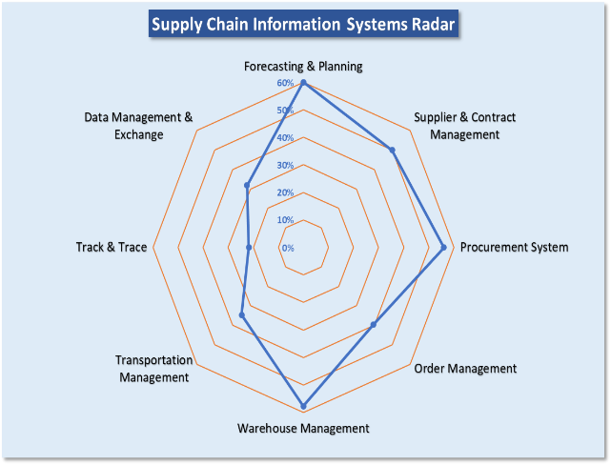The SCISMM score dashboard on the right illustrates the performed activities of each category based on the answers provided. For every category an individual score is calculated as the percentage of all activities within the 5 maturity levels that are actually performed.

* Forecasting and Planning: 60%
* Procurement System: 56%
* Supplier & Contract Management: 50%
* Order Management: 40%
* Warehouse Management: 58%
* Transportation Management: 35%
* Track & Trace: 22%
* Data Management & Exchange: 32%

Figure 2: SCIS Score Dashboard – CMST

## SCISMM Maturity Level Chart

The maturity level chart below summaries the percentage of performed activities of each maturity level.

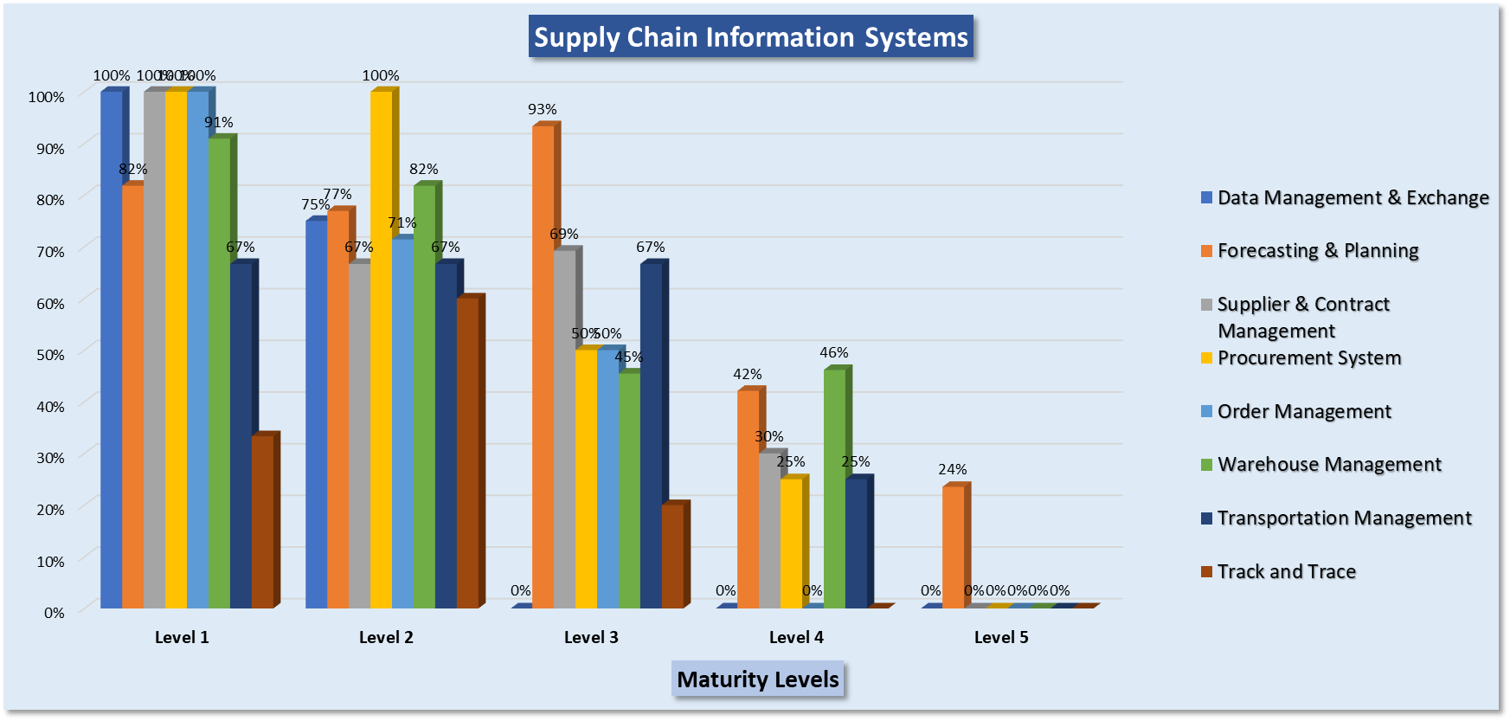

Figure 3: SCISMM Maturity Level Chart – CMST

## Score and Maturity Level Analysis

This section summarized the findings and observations of each function category per feedbacks and recommendations received through the key stakeholder interviews.

### Forecasting and Supply Planning

The Forecasting and Supply Planning category scored an overall of 60% and it’s within the advanced digitization level (Level 3). Findings and observations include:

* Key data of demand/consumption/supply planning are captured electronically using Excel spreadsheets.
* Excel spreadsheets with advance criteria (based on experience and lessons learned) are used to facilitate the forecasting, supply planning exercise on a quarter, semi-annual and annual basis.
* Historical files of orders and stock status of health facilities are maintained for future reference.
* Manual operation is required for data consolidation, which consumes additional resources.
* Standalone data source, with no mechanism for data sharing.

### Supplier and Contract Management

The supplier and contract management category scored an overall of 50% and it’s within the advanced digitalization level (Leve 3). The evaluation was based on the procurement operation at CMST for essential medicines and GoM sponsored products. Findings and observations include:

* Majority Key data of suppliers and contracts are captured electronically using Words, Excel spreadsheets and or pdf files.
* Contracting operation are performed manually without an information system. The signed contract and key data elements are entered to the Navision ERP system to create the Purchase Order and to trigger upcoming receiving process.
* Excel spreadsheets with some advanced criteria (based on supplier performance, supply capability, etc.) are used to track supplier information, performance, and contract status.
* Historical files of supplier’s profiles and service and contracts details are maintained within CMST internal network for records and future audit.
* Manual operation is required for data consolidation, additional resource is required.
* Standalone data source, without mechanism for data sharing.

### Procurement System

The procurement system category scored an overall of 56% and it’s within the advanced digitalization level (Leve 3). The evaluation was based on the procurement operation at CMST for essential medicines and the Government of Malawi (GOM) sponsored products. Findings and observations include:

* Donor leverages its own IT solution for procurement, while CMST procurement process is completely manual operation; GHSC-PSM (ARTMIS); GF (WAMBO) and CMST (Excel and Words) for RO, RFQ, contracts, etc.
* Procurement operation is well performed within CMST regardless of methodologies and tool used.
* Majority key data of supplier and contract are captured electronically using Words, Excel spreadsheets and or pdf files.
* Tendering and procurement process are performed manually in accordance with its standard operating procedure but without an automation tool. The vendor proposals are received via email and manually distributed for review. Proposal decision and contract award are also performed manually without an automate information system. Email is the primary method for communication.
* Key elements of contract details are captured in the Navision ERP for communication and records, and for the products receiving.
* Special order manager at CMST is in charge for the procurement of non-catalog items.
* Standard format of Word files and Excel spreadsheets are available for customization and to be compliant with organizational rules.
* Signed hardcopy document and pdf files are maintained within CMST internal network for records and future audit.
* Manual operation required for data consolidation, which consumes additional resource.
* Standalone data source and operation without mechanism for data sharing with other internal and external information systems.
* e-GP (Government Procurement) system, funded by the World Bank, will be rolled out across all government agencies for a centralized procurement operation nationwide per PPDA ([Public Procurement and Disposal of Assets Authority](https://www.ppda.mw/)) via the PPPC (Public Private Partnership Commission). Operational date is to be determined.
* CMST receives the advanced shipment notification (ASN) and enter to Navision for receiving to conclude the procurement process.

### Order Management

The order management category scored an overall of 40% and it’s within the transactional level (Level 2). Findings and observations include:

* Two (2) systems are used for order management at CMST; OpenLMIS (implemented by the GHSC-PSM project) and Order Online (developed internally).
* Branch managers of CMST download order information in Excel and or pdf format from OpenLMIS.
* OpenLMIS provides capability for District office to enter stock information received from health facilities and review and approve the request by the District Health Officers (DHOs). Once the orders are approved by DHOs, it will be accessible to the CMST branch managers to review, approve and upload to the Navision ERP system for distribution operation at warehouse.
* The Online Ordering system, developed by CMST IT team, is/has been used for HFs to submit orders for emergency case or products not available in the OpenLMIS system. It is anticipated the Online Order system will be retired soon and the OpenLMIS will be the primary tool for orders.
* Branch managers of CMST print out the stock inventory information from the Navision ERP system as reference while reviewing orders submission.
* Distribution note is generated for fulfillment. Per CMST’s policy, all orders will be delivered within 10 working days.
* No electronic solution implemented to support the order submission from customers (HFs, hospitals, etc.,) and integration to the Navision ERP at CMST.

### Warehouse Management

The warehouse management category scored an overall of 58% and it’s within the advanced digitalization level (Leve 3). CMST is the designated organization for warehousing and distributing for the essential medicines and GOM sponsored products. CMST has three regional warehouses (North, Central and South) for storage and warehousing products received from the central warehouses. Distribution to health facilities is delivered from regional warehouses. Findings and observations include:

* Orderly and clean central warehouse at Lilongwe with 2000+ pallets. Mainly paper-based operation manually in the warehouse, no real time data capturing into the Navision system.
* Plan to build a new warehouse with 30,500+ pallets capacity to be the central warehouse for receiving and warehousing all products of all programs in country. Estimated completion in 2-3 years.
* Standard product code and bin location are used for operation. Global standard information has not been introduced to the organization.
* Navision warehouse module is used for receiving and dispatching and system is available at the administration area within the central warehouse.
* A new MACS WMS system has been installed at CMST to replace the warehouse module provided in the Navision. No configuration and/or customization being done to support CMST warehouse operation as the time this report being developed.
* Planning to rollout the barcode scanner with the MACS WMS system for receiving, put-away, picking and distribution in the future. Timeline is to be determined by CMST.
* Planning to integrate with the National Product Catalog (NPC) program to adopt the GTIN/GS1 product information.
* Standard operating procedures (SOPs) for warehouse operation are available.
* Paper stock inventory sheets are used in central warehouse for operation.

### Transportation Management

The transportation management category scored an overall of 35% and it’s within the transactional level (Level 2). Findings and observations include:

* Excel and personal experience are the primary criteria for route planning and management. No automated tool leveraged.
* CMST owns a fleet of vehicles to distribute products from the central warehouse to the relevant regional warehouses. The 3rd party logistics companies are engaged to distribute products from regional warehouses to health facilities.
* Paper forms are used to plan and manage the transportation execution including progress, status of products (shipped, in-transit, delivered, etc.)
* A paper-based Proof of Delivery (PoD) document with signature from health facilities is used to confirm order fulfillment. The PoD is not uploaded to Navision ERP system for record, it is scanned and uploaded to CMST’s website for records.

### Track and Trace

The track and trace category scored an overall of 22% and it’s within the transactional level (Level 2). CMST establishes a unique product id/code for all products stored at its warehouses. Products can be tracked and traced within CMST’s operation territory (e.g., starting from receiving products to health facilities) but can’t be tracked and traced outside this boundary. Findings and observations include:

* CMST publishes its own product catalog with its own product code for ordering purpose. The unique product code is the primary key for track and trace within CMST organization.
* The unique CMST product id/code could track the information of supplier and trace the products to the districts and health facilities where the product is delivered using the Navision ERP system.
* Product information of CMST can be exported to Excel spreadsheet for data sharing manually on an as needed basis.
* A national product catalog (NPC) program with the standardized GTIN/GS1 compliant has been implemented to establish a standard product information in country. CMST is in process of integrating with the NPC to the standard product data.

### Data Management and Exchange

The data management and exchange category scores an overall of 32% and it’s within the transactional level (Level 2). Findings and observations include:

* Export data to Excel spreadsheets for data exchange is the primary method today
* Standard national product, facility and supplier master datasets have been established, but no systematic mechanism for managing and maintaining master datasets to ensure consistency across all systems.
* Standalone data source in hardcopy documents. Organizations enter data to their systems manually based on the published hardcopy document. No continuous maintenance method available to ensure the accuracy.
* GFPVAN, Global Family Planning Visibility and Analytics Network, a control tower platform, captures data from multiple sources to assess supply needs, prioritize them, and act when supply imbalances loom and to transform how supply chain decisions making.
* Malawi is a Premium membership of the GFPVAN.

# Maturity Score and Observations – GHSC-PSM Supply Chain Operation

GHSC-PSM program manages the forecast, planning, procurement activities for the USAID supported products. 3PL, Cargo Management Logistics (CML), has been engaged for warehousing and distribution.

## Information Systems/Tools Leveraged

Summarized below are information systems (ISs) and tools used/implemented within the GHSC-PSM supply chain operation for all programs supported by USAID. There are 2 separated operations within the GHSC-PSM, the GHSC-PSM field office is responsible for the forecast, planning, procurement, and order management while the 3PL subcontractor, Cargo Management Logistics (CML), is responsible for the warehousing and distribution of the commodities for the USAID supported products.

GHSC-PSM leverages the following systems:

* ATRMIS – Procurement
* Pipeline – Supply Planning (QAT soon)
* Quantimed – Forecasting
* OpenLMIS – Requisition and Reporting and Order submission
* National Product Catalog (NPC) – Standardize GS1 compliant product master data
* GFPVAN – Global Family Planning Visibility & Analytics Network

3PL, CML manages the warehousing and distribution of the GHSC-PSM products.

* Sage Evolution 200 – ERP
* UrbanCode – WMS (customized)
* Freight Focus – Mobile application for Transportation and Distribution

## SCISMM score dashboard

Two dashboards are generated via the SCISMM interview: the SCISMM score dashboard and maturity level chart of each supply chain functional category.

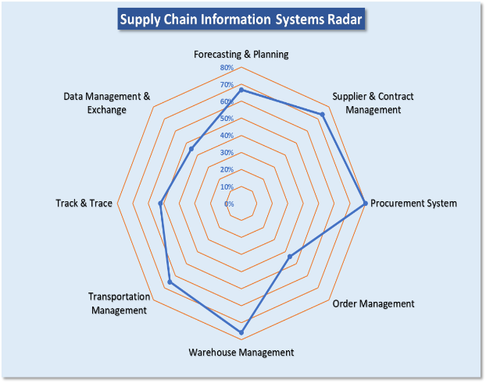The SCISMM score dashboard on the right illustrates the performed activities of each category based on the answers provided. For every category an individual score is calculated as the percentage of all activities within the 5 maturity levels that are performed.

* Forecasting and Planning: 67%
* Procurement System: 80%
* Supplier & Contract Management: 74%
* Order Management: 44%
* Warehouse Management: 76%
* Transportation Management: 65%
* Track & Trace: 52%
* Data Management & Exchange: 45%

Figure 4: SCISMM Score Dashboard – GHSC-PSM

## SCISMM Maturity Level Chart

The maturity level chart below summaries the percentage of performed activities of each maturity level.

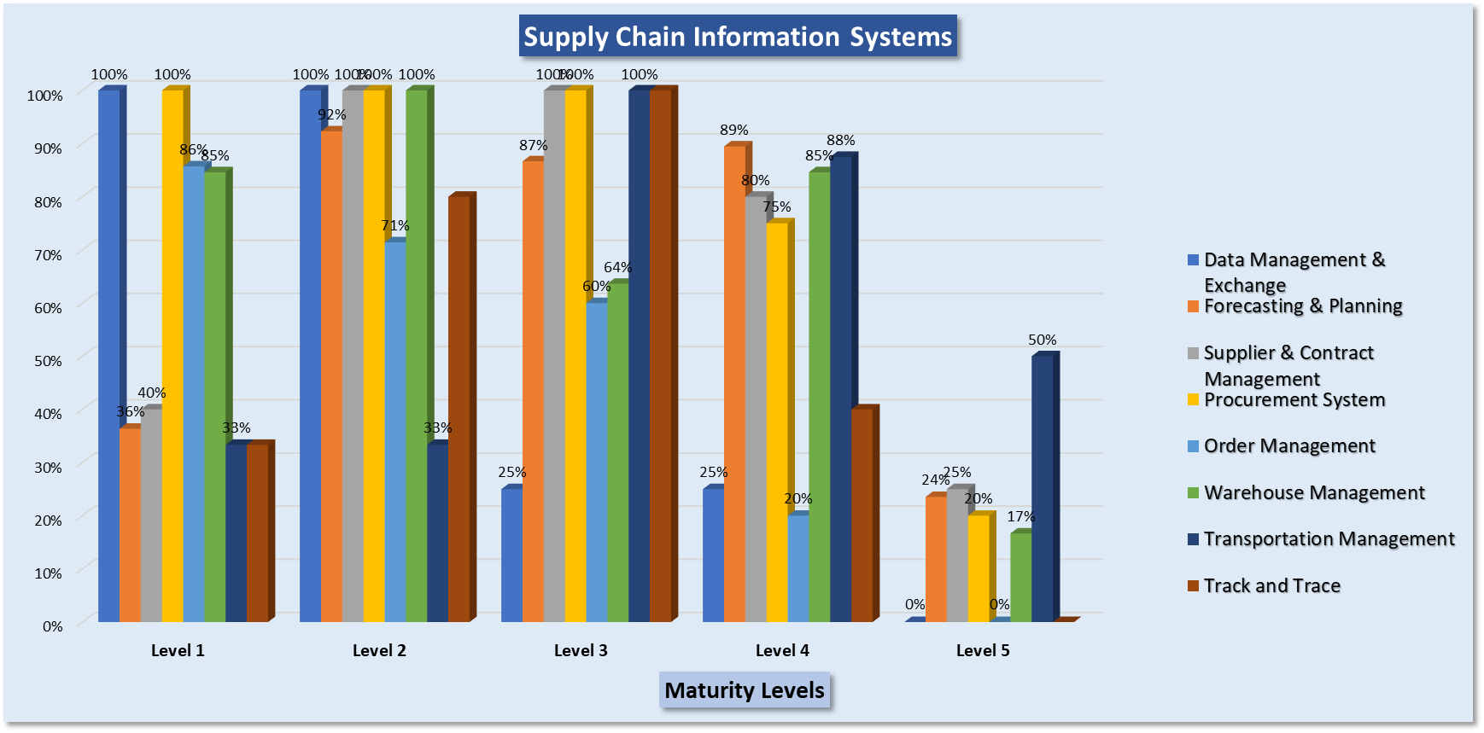

Figure 5: SCISMM Maturity Level Chart – GHSC-PSM

## Score and Maturity Level Analysis

Summarized below is the findings and observations of each function category per feedbacks and recommendation received during the key stakeholder interviews.

### Forecasting and Supply Planning

The Forecasting and Supply Planning category scored an overall of 67% and it’s within the transactional level (Level 3). Findings and observations include:

* OpenLMIS is the primary data source for the forecasting and planning in conjunction with the treatment data from the DHIS2.
* Key data of demand/consumption/supply planning are captured electronically using the Quantimed (Forecasting) and Pipeline (supply planning) tools
* Advanced criteria (based on experience and lessons learned) have been incorporated to both Quantimed and Pipeline tools to support the national exercises.
* Both tools have the capability to host the historical records for reference and trend analysis.
* Manual operation is required for data consolidation, which consumes additional resources.
* Standalone data source, with no mechanism for data sharing.

### Supplier and Contract Management

The supplier and contract management category scored an overall of 74% and it’s within the advance End to End Visibility level (Leve 4). The evaluation was based on the procurement operation at GHSC-PSM Headquarter, located in Washington DC. Findings and observations include:

* ARTMIS, comprehensive procurement ERP system, has been leveraged for procurement operation in accordance with the US Federal Acquisition Regulation (FAR) to support order, supplier, contract and shipment operation.
* Majority Key data of supplier and contract are captured electronically in the ARTMIS system and can be exported to Words, Excel spreadsheets and or pdf files as needed.
* Partial contracting operation is performed using other automated tools in addition to the ARTMIS system.
* The advanced shipment notification and contract information are accessible by the designated project members.
* Historical files are maintained within ARTMIS for records and future audit.
* Data sharing and system integration with QAT, PPMR, and GFPVAN are in place. Not direct data sharing to the information systems implemented in country.

### Procurement System

The procurement system category scored an overall of 80% and it’s within the advance End to End Visibility level (Leve 4). The evaluation was based on the procurement information system, ARTMIS (Automated Requisition Tracking Management Information System), implemented at GHSC-PSM Headquarter located in Washington DC. Findings and observations include:

* ARTMIS is a cloud-based solution and it automates core supply chain business process including demand & supply planning, catalog management and order processing, sourcing, order fulfillment, order tracking, transport management, inventory management, financial management QA/batch control, optimization, performance report and dashboards, warehouse management.
* Order requests from countries are manually entered to the ARTMIS to trigger the procurement process.
* Tendering and contract operations are performed manually in accordance with its standard operating procedure but without an automation tool. The vendor proposals are received via email and manually distributed for review. Proposal decision and contract award are also manually without an automate information system. Email is the primary method for communication.
* Contract details is captured within GHSC-PSM HQ for audit and records
* Advanced shipment notification (ASN) is distributed from suppliers to countries directly via email to trigger in country clearance process.
* Standard format of Word files and Excel spreadsheets is available for customization and to be compliant with organizational rules.
* Signed hardcopy document and pdf files are maintained within GHSC-PSM HQ for records and future audit.

### Order Management

The order management category scored an overall of 44% and it’s within the advanced digitization level (Leve 3). The evaluation was based on the order operation in country, e.g. health facilities submit requisition and report and information entered to the OpenLMIS system. This is not the order process indicated in the procurement system above where the field office (FO) submits the aggregated national orders (request order, RO) to the ARTMIS system for procurement. Findings and observations include:

* Paper-based requisition and report (R&R) form is printed and distributed to the health facilities for monthly stock count. Health facilities provide the stock status based on the defined data elements on the R&R form and submit it to their associated district health office for review and to be entered to the OpenLMIS system. The approved R&R information then is converted to the orders to be accessible by the CMST and GHSC-PSM team for their further processing.
* For the GHSC-PSM program, the order information will be exported to Excel spreadsheets and be sent to the 3PL via email for distribution.
* No direct interface and data sharing between the GHSC-PSM FO and 3PL in country.
* 3PL, CML, enters the received orders to the Sage ERP system for warehouse operation.
* Distribution note is automatically generated for fulfillment. Per CML’s policy, all orders will be delivered within 10 working days.

### Warehouse Management

The warehouse management category scored an overall of 76% and it’s within the end to end visibility level (Leve 4). The 3PL, CML, is the designated organization for warehousing and distributing of all health products of the GHSC-PSM program. Findings and observations include:

* The UrbanCode WMS system is used to manage the warehouse operation and it is integrated with the Sage ERP system at CML. The systems are operated within CML’s premises only.
* Barcode scanners are used throughout warehouse operation for real time data entry and verification such as receiving, put-away, picking and packing as well as distribution order checking for confirmation prior to seal the package.
* Standard operating procedures are defined, staff is well trained and follow the SOP for operation.
* CML’s specific product code and warehouse bin location codes are well defined and implemented in the WMS system. Global standard information has not been introduced to the organization.
* GHSC-PSM FO delivers the advanced shipment notification (ASN) and send to CML for receiving when it is available. Should the ASN be unavailable, and the products have arrived at CML warehouse (a rare situation), CML informs the GHSC-PSM FO with the status and starts receiving products using the invoice attached to the shipment vehicle.
* Conduct monthly stock count at warehouse for inventory management and control. Standard SOPs also defined and executed accordingly.

### Transportation Management

The transportation management category scored an overall of 65% and it’s within the end-to-end visibility level (Leve 4). Findings and observations include:

* The Freight Focus system, mobile application, is used for route planning and management. The application is integrated with the UrbanCode, WMS, to receive the order and delivery invoice detail.
* Freight Focus system captured the location of the beginning and end points of the delivery. Location points of the entire delivery route is not captured. Google map is used to monitor moving and location of the vehicle.
* CML owns a fleet of vehicles for distribution to all customers per order information.
* Broadcasting and personal experience are leveraged for routing planning and optimization as needed.
* The Proof of Delivery (PoD) document can be captured in the Freight Focus system with signature from health facilities. The PoD remains in the system, did not upload to Sage ERP nor the WMS system.

### Track and Trace

The track and trace category scored an overall of 52% and it’s within the advanced digitization level (Level 3). The 3PL, CML, establishes a unique product id/code for all products stored at its warehouses. Products can be tracked and traced starting from receiving products to the health facilities and potentially to the SDPs and clinics. Findings and observations include:

* The CML unique product id/code could be used to track the information of supplier and trace to the health facilities where the products were distributed to and potentially to the SDPs and clinics.
* The eHIN system, funded by the UNDP, has been rollout to the SDPs and clinics levels to track the stock information and dispensing detail. The products information of health facilities are captured to the eHIN for the last miles operation.
* CML can leverage its unique product code to query information through the 3 internal information systems for the products sponsored by USAID. No integration with the MoH products managed by CMST.
* Product information of CML can be exported to Excel spreadsheets for data sharing manually on an as needed basis.

### Data Management and Exchange

The data management and exchange category scores an overall of 45% and it’s within the advanced digitization level (Level 3). Findings and observations include:

* An OpenHIE platform has been developed to establish an interoperability layer for data exchange and integration among the implemented systems. The OpenHIE platform has not been rollout for data exchange as the time of this report being developed.
* Digital Health Technical Working Group has been formed to establish digital strategy for building an unified information system for the national supply chain operation.
* There are more than 20 information systems that have been implemented by MoH, donors and stakeholders to support its supply chain operation. All systems are operated standalone.
* Export data to Excel spreadsheets for data exchange is the primary method today
* No standard national product, facility and supplier master dataset is established, and no systematic mechanism defined for managing and maintaining master datasets to ensure consistency across all systems.
* Standalone data source in hardcopy documents. Organizations enter data to their systems manually based on the published hardcopy document.
* GFPVAN, Global Family Planning Visibility and Analytics Network, a control tower platform, captures data from multiple sources to assess supply needs, prioritize them, and act when supply imbalances loom and to transform how supply chain decisions making.

# Systems operation at facility level Observed

During the SCISMM assessment, two electronic logistics management information systems (LMIS) implemented at health facilities for a different purpose were observed.

**OpenLMIS**: to capture stock information of health facilities monthly. In addition, the stock management module of OpenLMIS has been rollout at health facilities to capture the transactional stock records to improve the accuracy and availability of stock information.

OpenLMIS is used to report stock status for all programs. It has been rolled out to more than 700 health facilities in country.

**eHIN:** a mobile application deployed at health facilities to track the transactional dispensing data at SDPs and clinics. Staff at health facilities conduct stock counts and entered the stock data to eHIN prior to the dispensing operation.

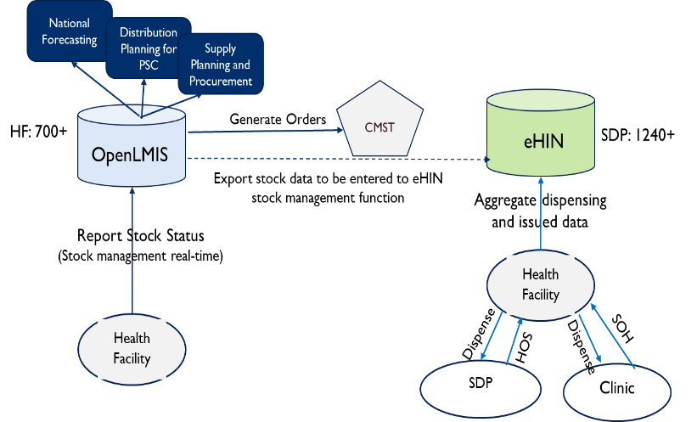eHIN is used to capture the dispensing data for vaccines (excluding COVID 19 vaccines) at the time this report being developed. It has been rolled out to more than 1240 SDPs and clinics of health facilities in country.

The diagram shown on the right depicts the current operation between OpenLMIS and eHIN system.

Per observation, the operation of the two systems would potentially provide an end-to-end data visibility of the supply chain operation if a detailed integration method was defined and implemented.

Figure 6: LMIS systems at health facility

# next stepS

There is numerous parallel supply chain operation in country, and more than twenty information systems implemented by various stakeholders (GOH, donors, etc..). Defining a unified digital strategy would provide opportunity for building an integrated information system for the national operation.

The Supply Chain Information System Maturity Model (SCISMM) assessment done in June, focused on identifying the capability implemented in the current information systems including strengths and weakness which can be leveraged for a development of the digital health strategy. The GHSC-PSM HQ team proposes conducting workshop/s with key stakeholders to present and facilitate discussions on recommended digital supply chain improvements. Key activities of the workshop/s will include

* Present a recommended technical architecture that is geared towards enabling Malawi’s health supply chain to increase its efficiency and end-to-end visibility, while preparing it to respond better to health emergencies.
* Provide a recommended roadmap to implement the prioritized digital supply chain improvements. The roadmap will also include immediate term activities that are quick wins to integrate and leverage available systems and gain efficiencies while waiting for longer term improvements.
* Facilitate outlining of next steps and timelines in development of Malawi’s digital supply chain strategy and architecture.

## SCISMM Q&A

The SCISMM document provides recommendations for continuous improvement by establishing the activities and key performance indicator (KPI). The questionnaire could be leveraged as a continuous assessment tool to evaluate progress of defined KPI objective on the self-defined time-period. Attached is the final version of the SCISMM questionnaire, dated June 18th 2021, with responses and comments from all interviewees.

 